**T2** 2023

Coverity Scan Static Analysis Report

Hardhard Enterprises

Statement of Intent

Overview

This document aims to provide a record of static code analysis performed on a specific issue from the Coverity SAST scan for the NASA ION Open-Source code 4.1.1 project.

The primary purpose of this document is to validate the issue identified via the automated detection process to eliminate false positives.

Depending on findings, secondary purposes can include but are not limited to listing/providing recommended fixes alongside a list of attack vectors and potential exploits for consideration.

Reporting Best Practices

Please ensure best practices are kept when completing the document via regularly updating the Acronyms and Abbreviations table alongside any iterations made to the Document History table. This will allow other members to identify any updates and progress made across trimesters easily.

When using code snippets, please use screenshots that are clear and easy to read, alternatively, use words built-in code formatter found [here](https://appsource.microsoft.com/en-us/product/office/WA104382008?tab=Overview).

Document Naming Conventions

Naming conventions for this file are as follow; SAR_{CID}. For example, when investigating issue 123456 the file name would be SAR_123456.docx

Document History

|  |  |  |  |
| --- | --- | --- | --- |
| **Dates** | **Version** | **Author** | **Comments** |
| 14/09/2023 | V0.1 | LIANG CHEN | Analyze Improper Input Validation |
|  |  |  |  |
|  |  |  |  |

Table of Content

Contents

Introduction 3

Objective 3

Scope 3

Acronyms and Abbreviations 3

Code Review and Analysis 4

Outcomes 4

Observations 4

Supporting Evidence 4

Conclusions and Recommendations 5

References 6

Appendix 7

# Introduction

## Objective

The primary objective of this analysis is to determine whether the defects identified in the Coverity Report for the ION Open Source 4.1.1 project are:

* Indeed, defects.
* Potentially exploitable.

The secondary objective of this analysis, where applicable, is to provide the following:

* Recommendation(s) to fix.
* Any exploit for consideration.

## Scope

This static code analysis is limited to the ***Improper Input Validation*** type defect identified in the following CIDs:  
***1520763***

# Acronyms and Abbreviations

Please keep an updated list of acronyms and abbreviations used throughout the report.

|  |  |
| --- | --- |
| **Acronym** | **Meaning** |
| DTN | Delay/Disruption Tolerant Network |
| ION | Interplanetary Overlay Network |
|  |  |

# Code Review and Analysis

## Overview

## This report delves into the analysis of detected issues within the decodeHeader function found in the libbp.c file and its associated decoding functions. The focal point is the management of untrusted or "tainted" data, which might lead to potential security vulnerabilities.

## Observations

## The primary issues pinpointed in the shared code fragments pertain to the possible mismanagement of tainted data. If this tainted data isn't adequately validated, it could result in unexpected behaviors or security vulnerabilities within the software.

## Supporting Evidence

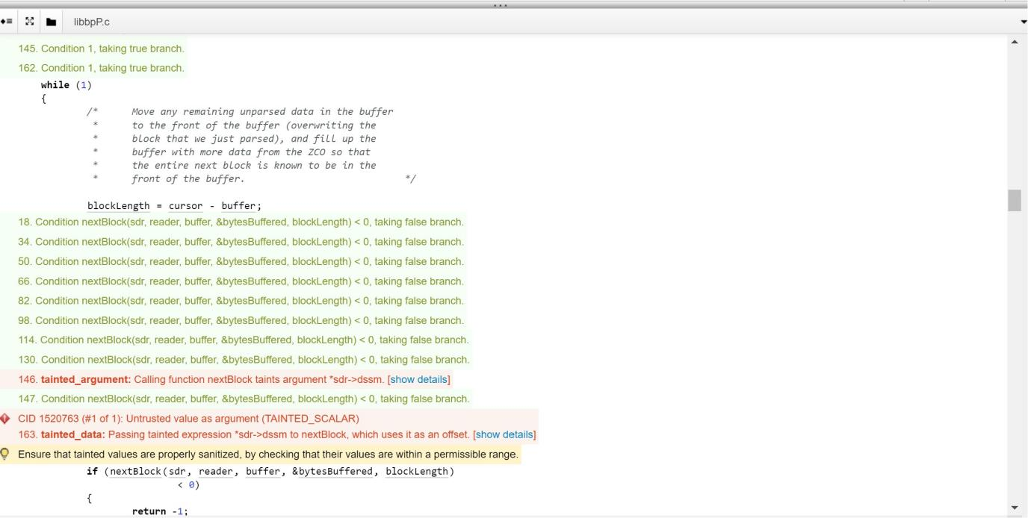

Within the decodeHeader function, the cursor variable obtains data from an external source, likely related to the corresponding data packet. This data is then relayed to various cbor_decode and acquireEid functions without sufficient validation.Throughout the decoding process, the potentially tainted cursor is utilized to fetch and parse data. This data directly influences subsequent decoding and processing steps.

# Conclusions and Recommendations

The overarching concern throughout the file is the potential mismanagement of untrusted data. If not appropriately sanitized, this could lead to vulnerabilities, especially if it impacts memory operations or other pivotal functionalities. It's recommended to ensure proper validation and sanitization before processing any data received externally.

References  
Please keep an updated references list in APA7; The Deakin referencing guide can be found [here](https://www.deakin.edu.au/__data/assets/pdf_file/0009/2236752/Deakin-guide-to-APA7.pdf).

7 Pernicious Kingdoms (CWE Draft 3, 2006-07-19, Submitted on July 19, 2006).

<https://cwe.mitre.org/data/definitions/20.html>

Appendix

Include additional information/documentation here to help the readers understand complex information.